Methods of Linear Regression Documentation
Abstract
This project implements linear regression using three distinct methods: a statistical method using covariance and variance, a matrix method using the normal formula, and a machine learning method using gradient descent. The goal is to compare their practical tradeoffs.
Introduction
A linear regression is a specific model used to analyze data where a line is constructed to approximate values based on the given inputs and reflect the trend across data points. Some examples include: Sales Forecasting, Demand Prediction, Risk Modeling, and Pricing Models.
In this project, the methods are implemented as pricing models for the housing market using data collected from a US census.
Data:
- x = x₁, x₂, …, x_{n}
- y = y₁, y₂, …, y_{n}
In each method, the goal is to solve the same underlying equation, y = mx + b
Methods
Statistical Approach:
The first approach that was explored was using probabilistic techniques. It can be difficult at first to conceptualize how Probability and Machine Learning are related so first, let’s define the term, Machine Learning. One could say that Machine Learning is the use of mathematical techniques to teach machines how to execute tasks with as minimal mistakes as possible. In other words, researchers and developers use approximations to get as close to the correct answer as possible. This leaves room for an acceptable amount of variance between answers. That variance is what is used to construct the slope for this approach.
The full formula for this implementation is: m = Cov(x, y) / Var(x). Covariance can be described as the measurement of how linearly the x and y values are related and variance, as described before, is the measurement of how dispersed the x values are from the mean. This means that the formula could be read as how related x and y are divided by the relationships of the x values relative to the mean. When phrased like this, the similarities between this definition and the definition of slope, which is commonly known as the “rise” divided by the “run”, becomes clearer. This formula is how we calculate the slope for our line. However, when using the equation y = mx + b, there needs to be more information than the slope.
For the b variable, it can be determined by using the same algebra skills. If given y, m, and x, b can be found by rearranging the formula to b = y – mx. Due to x and y representing row vectors or features, they must be represented as the mean of those values which translates to taking the mean of all y values and subtracting the product of the slope and the mean of all x values. This turns the equation to b = $\overline{y}$ - m$\overline{x}$. This provides all the tools needed to calculate the exact y value of every x value within the dataset.
In practice, it’s important to note that due to the nature of the model, each element must be traversed to calculate the average. If we were to represent that total as n, the program must look at n elements to calculate the mean and n elements to calculate the Variance and Covariance. This would mean that at the bare minimum, this implementation must be O(n) in computational time complexity. Additionally, the amount of additional memory used as the computation grows remains constant, making the spatial complexity O(1). This will be carefully noted as we compare this analysis to the other implementations.
Matrix Approach:
The second approach that was explored was using matrix multiplication techniques. The full formula is written as such: θ = ((X^{T})*X)⁻¹ * (X^{T})*Y. The theta in this application will be a 2x1 matrix of the slope and intercept. The way this implementation works is by taking the x vector and turning it from an Nx1 matrix into an NxD matrix. This is done by concatenating padding onto the vector to change the shape for the intercept. Afterwards, this is transposed. Transposition takes the number of rows and columns and switches them. This would mean for our NxD matrix, the transposition would become a DxN matrix. This is denoted by a T in the superscript of the original matrix. This provides the conditions needed for matrix multiplication because there exists both a DxN matrix and an NxD. The product of these matrices produces a DxD matrix. Afterwards, this matrix is inverted. Next, the DxD matrix is multiplied by the transpose matrix X^{T} which produces a DxN matrix. Once multiplied by the y vector, which is an Nx1 vector, the final matrix will be a Dx1 vector.
From a computational viewpoint, this method requires more computation over time compared to the previous implementation. Let’s start from the beginning of the implementation. The concatenation procedure involves appending a column of 1s to the vector which would involve going over every row and adding a 1 in the next column. If the number of rows traversed are represented as n, this would make the procedure an O(n) procedure. It’s also important to mention that depending on the implementation, one may have to copy every element from the vector into another memory location with the new memory of the additional column reserved. This would also be an O(n) time and spatial complexity procedure with n representing the total amount of elements in both vectors. So, this procedure has an average case of O(n) computational time complexity. After that, the transposition involves going through the matrix and changing the position of each number within the matrix. NumPy implements transposition as a view, so this step is O(1) in practice, however, it’s worth mentioning that a naïve implementation would be O(n·m) with m being the number of columns, and n being the number of rows. It’s also important to understand the worst-case scenario, which would be a square matrix. In the worst case, the n will be equal to the m. This would force the traversal to be an O(n²) procedure with n representing the number of given columns.
After transposition, the problem moves onto inversion of the matrix. In NumPy, inversion of a matrix is implemented using LU decomposition, which ends up being O(d³) with d being the number of columns in the matrix. The problem then shifts to matrix multiplication. To understand the complexity, it’s important to first understand how matrix multiplication between two matrices works. When taking the product between two matrices, the workflow is as follows: first, take the first row of the first matrix and multiply those features by the first column of the second matrix. The summation of this step gives one singular feature in the product matrix. Next, this process is repeated until the product matrix is filled. It’s important to note that the product matrix will naturally take the number of rows from the first matrix and the number of columns from the second matrix as its shape. To understand the complexity of this entire operation, it must be analyzed at each step. The first step is vector-by-vector multiplication. This can be written as $\sum_{\left\{i=1\right\}}^{n}{x_{i}y_{i}}$. This effectively means that each value in each matrix must be traversed over to produce a set of values. These values are summed up to produce one value. This is inherently an O(n) time complexity procedure where n is the problem size or in this case, the number of features. Afterwards, this one procedure must be done for each column within the first matrix (this size is also the exact number of rows in the second matrix as previously mentioned). This means to produce a product matrix, the O(n) procedure must be repeated d² times due to the matrix being a DxD shape. This makes the final complexity of this operation O(n*d²). In totality, this method has a computational time complexity of O(n*d² + d³). Since d is defined here as 2, this simplifies to O(n).
Regarding spatial complexity, the dominant space requirement comes from storing the concatenated feature matrix Xcon, which is an n×2 matrix requiring O(n) space, where n is the number of samples. The intermediate 2×2 matrices (X^{T}·X and its inverse) require only O(1) space. The temporary vectors created during matrix multiplication operations require O(n) space for intermediate computations but are reused and do not accumulate. Therefore, for this implementation, the spatial complexity is O(n) in the average case.
Machine Learning Approach:
The final approach explored was machine learning, specifically gradient descent. From a high level, this approach involves making predictions for the slope and y-intercept in a forward pass, comparing those predictions against the actual y-values to calculate how far off they are, and adjusting the slope and intercept accordingly in a backward pass. This cycle repeats until the model converges on stable values. The cost function used to measure this error is the Mean Squared Error formula, written as: (1/(2n))${\sum_{\left\{i=1\right\}}^{n}{((Y_train_{i}-Y_pred_{i})}}^{2})$. This means taking the difference between the actual y-values and the predicted values, summing the square of that difference across all data points, and dividing by 2n, where n is the number of data points. The scalar factor of ½ is used here to make for simpler derivatives moving forward. Including it or leaving it out doesn’t change the result, rather it changes the formula for the partial derivatives. Following, the partial derivatives of the cost with respect to the weight and bias are calculated, written as such: ∂L/∂w= -(1/n) ∑ X_train (Y_train_{i} – Y_pred_{i}) and ∂L/∂b= -(1/n) ∑ (Y_train_{i} – Y_pred_{i}). These derivatives indicate the direction and magnitude needed to adjust the weight and bias to reduce the cost and are used to update both values on each iteration: w = w – ε(∂L/∂w) and b = b – ε(∂L/∂b). ε is used to represent the learning rate.
In implementation, the code begins by initializing the weight and bias to random values. Since this is a single-feature model, only one weight and one bias are needed. The learning rate is fixed at 0.025, a value determined through experimentation, and the model trains for 10,000 epochs. Unlike the matrix and statistical methods, which fit on the entire dataset, this method uses an 80:20 train/test split, training only on the 80% training partition. This will be used later to test model accuracy. For each epoch, predictions are computed for the entire training set in a single forward pass, the cost is calculated using the formula above, the gradients are computed with respect to the weight and bias, and both are updated using the learning rate. This process repeats for all epochs, after which the final weight and bias values represent the model's learned slope and y-intercept.
From a computational standpoint, this approach explains itself very clearly. The setup prior to the loop are all O(1) procedures. The loop itself only runs k times with the assumption that k represents the number of epochs. Upon first glance, the loop only does assignments which are O(1) procedures, however, the sum function within NumPy is inherently an O(n) procedure where n is representative of the total length of a given input. This would mean each line that uses sum has a complexity of O(n). This would mean that for the loop, the overall time complexity would be O(n*k), where n is the size of the training set and k is the number of epochs; both of which are independent variables that scale the total cost. For spatial complexity, the cost, dw, and db calculations each rely on NumPy operations that allocate new arrays rather than modifying existing ones in place. This means every epoch allocates a fresh O(n) array, where n is the size of the training set, rather than reusing a single buffer across iterations. While this does not change the algorithm's asymptotic space complexity, which remains O(n), it does introduce repeated allocation and deallocation overhead across all k epochs. A more optimized implementation could avoid this by updating values in place, reducing overhead without changing the algorithm's underlying complexity class.
The final complexities for each approach as they are implemented are as follows, using the statistical approach produces a time complexity of O(n) and a spatial complexity of O(1) where n represents the problem size, the matrix approach produces a time complexity of O(n*d²⁺d³) and a spatial complexity of O(n) where n represents the problem size and d represents the amount of columns in the input, and the machine learning approach produces a time complexity of O(n*k) and spatial complexity of O(n) where n represents the size of the training set and k represents the number of epochs. Due to the code implementation having a constant value for d, all of these collapse to O(n).
 | Statistical | Matrix | Machine Learning
Time Complexity | O(n) | O(n) | O(n)
Spatial Complexity | O(1) | O(n) | O(n)

Results
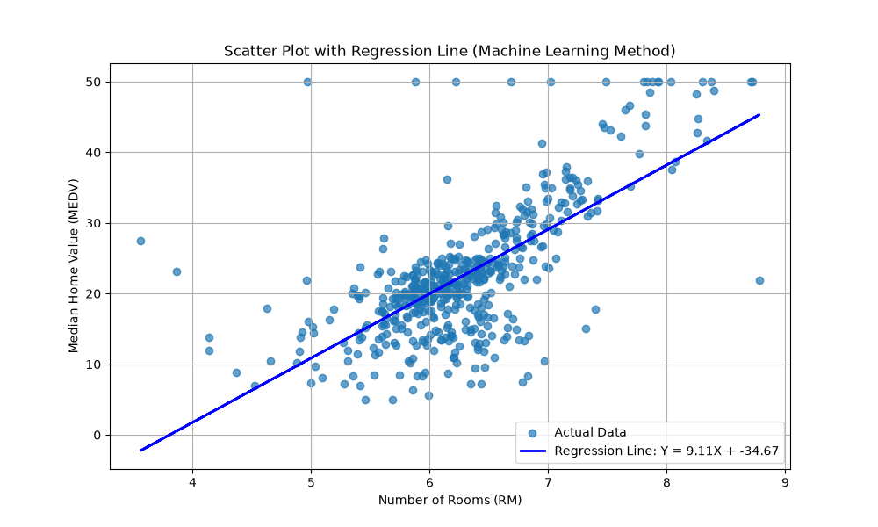
 | Statistical | Matrix | Machine Learning
Results | 9.10x – 34.67 | 9.10x – 34.67 | 9.11x – 34.67

Discussion
There’s a lot to address within the 3 different implementations. To compare each method, they must be looked at in totality. First, it’s important to recognize their inherent differences. The statistical approach and the matrix approach are both methods that give exact values of the line. With machine learning, the goal is like the previous methods, which is drawing an accurate line, however, it differs from the goal of giving an exact line. Machine learning accepts that it is more efficient to approximate and adjust these values accurately than it is to compute them exactly at scale. This may seem untrue at first, however upon further analysis, this can be attributed to the problem size. The dataset that was used has about 500 data points. Though this value seems like a substantial amount, in practice, it’s much more meager than it seems. In industry practice, there may be thousands or millions of data points. Once these numbers become larger, the key word “scale” becomes more important. Machine Learning was not the best approach for this dataset. For a smaller problem size the statistical and matrix approach can be better suited. However, this does not discredit the machine learning method in the slightest. For a fixed problem set like the dataset used in this project, machine learning is not well-suited but, for a forever growing dataset, machine learning would flourish where the other methods slow down for many reasons.
Within the complexity analysis for this project, the complexity of each method degenerated to O(n) roughly, however, it’s important to understand how they grow at scale. To analyze the time complexity for the matrix method at scale, the worst-case scenario has to be analyzed which would be whenever the matrix becomes a square matrix. This would force the d to be the same value as n which makes the overall complexity O(d³). Additionally, the spatial complexity would jump to O(n²). This is a huge jump over time compared to the O(n*k) and O(n) complexity of machine learning and a real risk to understand.
It’s also worth mentioning that throughout this project, there was an unexpected connection between two methods. The statistical method only applies to single feature regressions. Let’s explore what it would be like to expand this method into taking many features.

